Project Name – Verification Document

Project overview.
Short description of the DUT.
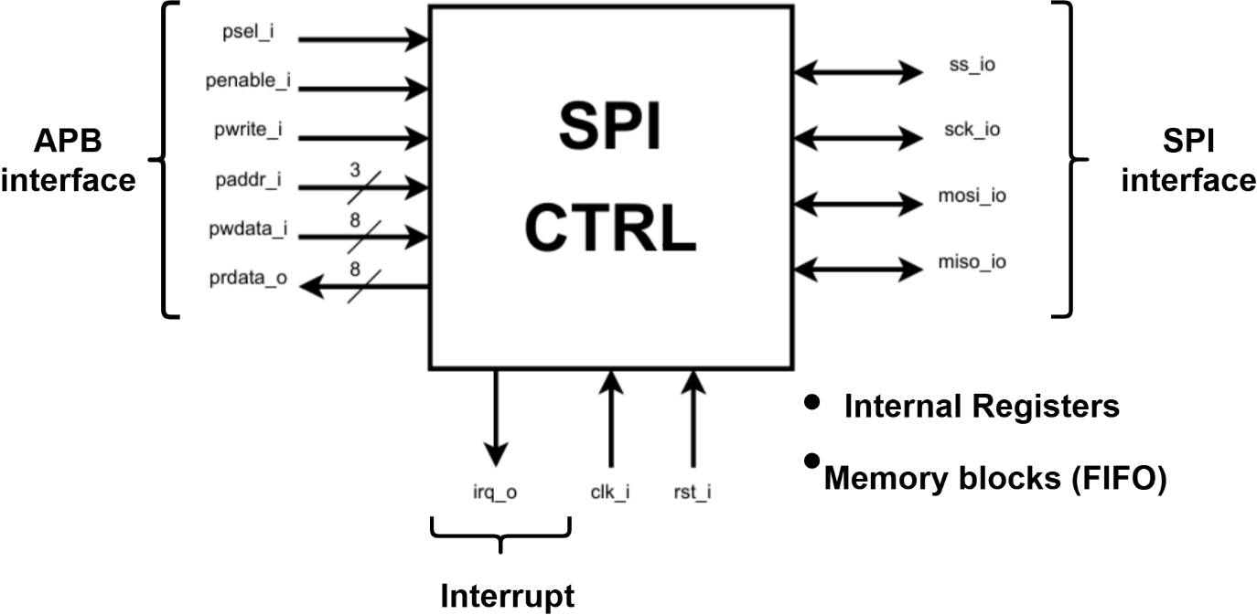
Figure of the DUT.
Specification reference.

Functional requirements.
  - Requirements
List of the requirements from the specification with each of their identifiers.
- REQ-001: The reset should always clear the address bus to address 0.
- REQ-002: etc.

Verification scenarios.
  - Normal operation
The DUT should follow the UART protocol exactly.
  - Boundary conditions
  - Illegal inputs
  - Simultaneous operations
  - Error conditions

Verification methods.
A documentation of the verification methods used and why:
- Directed tests for the specific requirements REQ1, REQ2, REQN.
- Randomized tests for coverage.
- Scoreboard.

Assertions.
A list of the neccesary assertions.
- Assertion 1: the psel_i signal should only assert on the posedge of the clock signal.

Functional coverage.
A list or table of the coverage elements: covergroups, coverpoints, cross-coverage.
Covergroup | Coverpoints | Cross-coverage

Environment draft.
Explain the general draft of the idea of how the verification environment will be implemented. Can be subject to change.
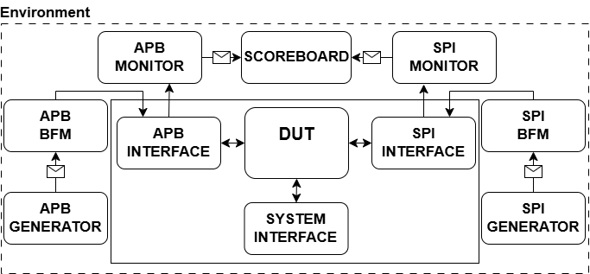
Environment figure.

Verification completion criteria.
Define what constitutes successful verification.

Revision history.
Version | Date | Description of changes
1.0 |  | Initial specification

